Q1~Q3:

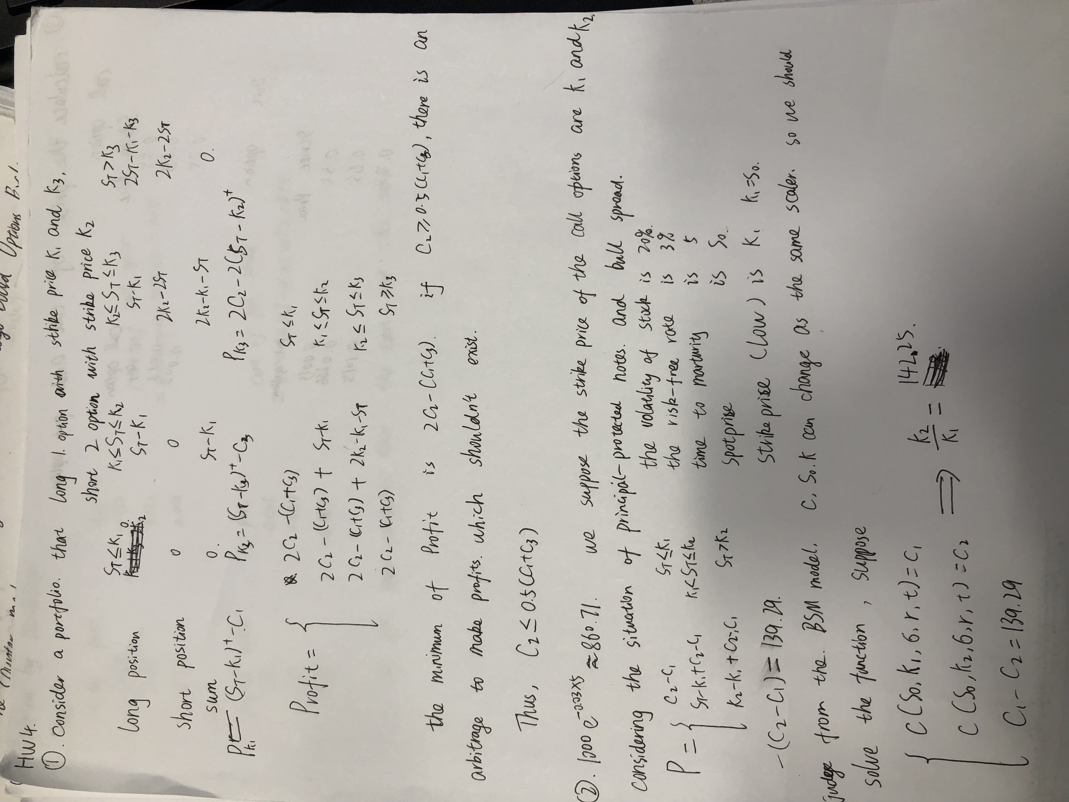

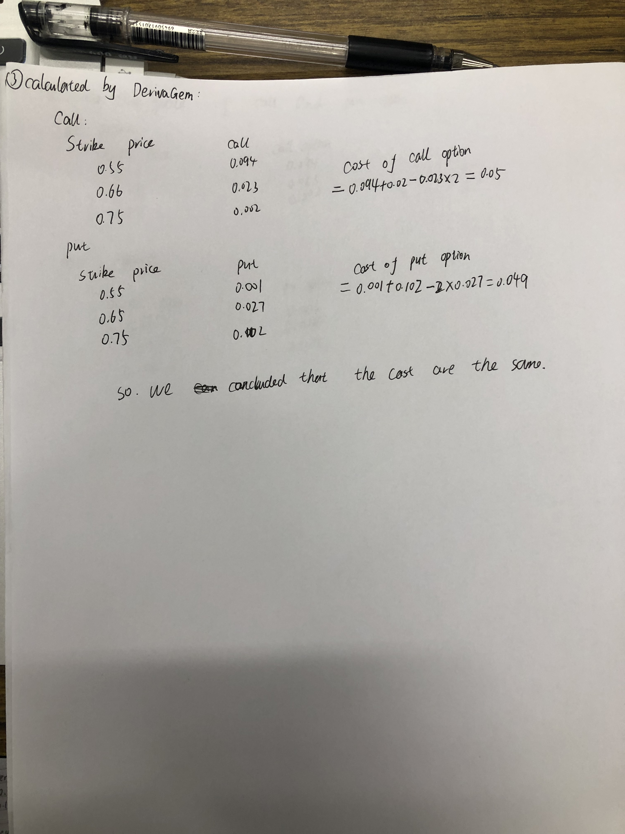

Q4:

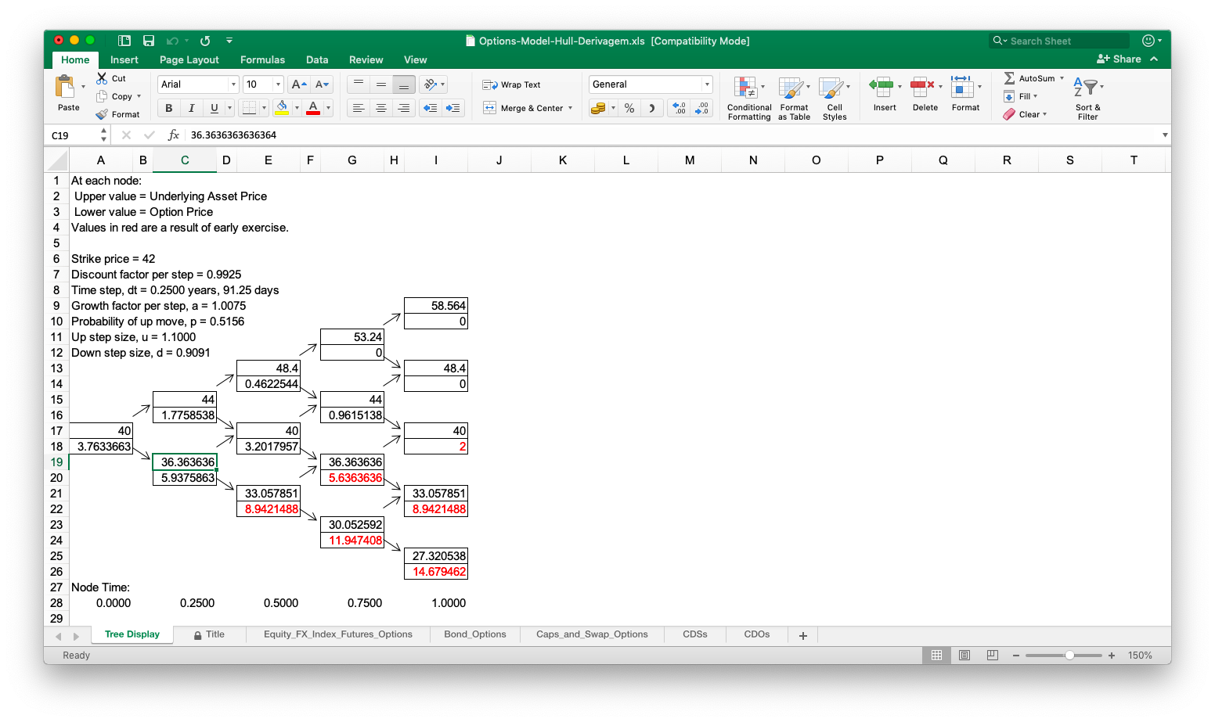

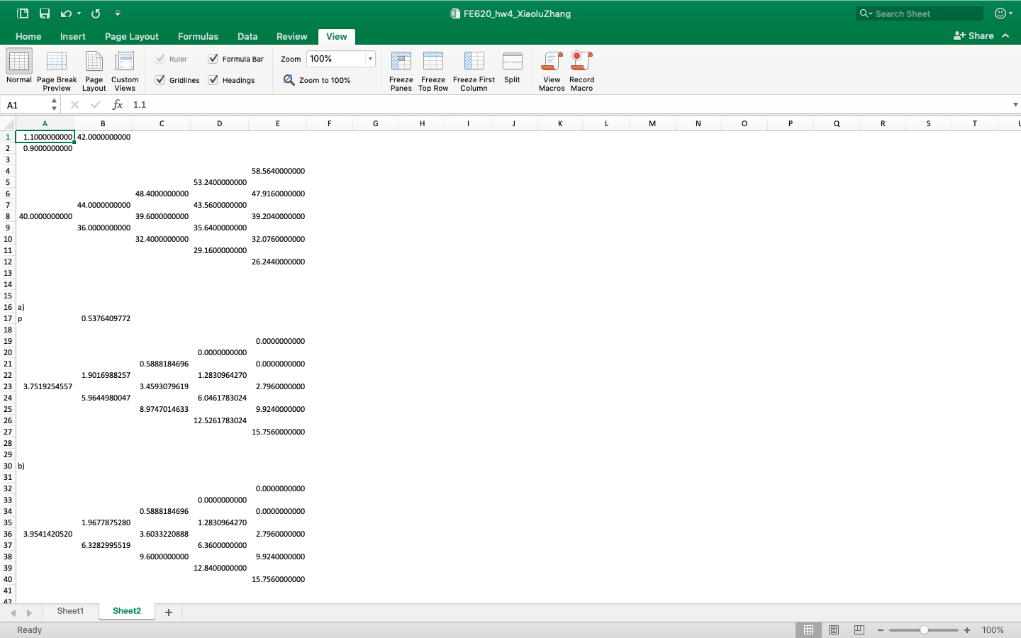

Use the different calculator,

when we use the DerivaGem:

The price of European put option is 3.544602

The price of American put option is 3.763366

Use my own excel to calculate:

The price of European put option is 3.7519254557

The price of American put option is 3.9541420520

Q5:

`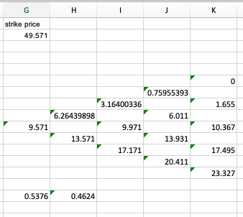

Calculated by the excel, we can get the strike price is 49.571